Press the Enter key to get a language screen and then choose the language for the OS installation.

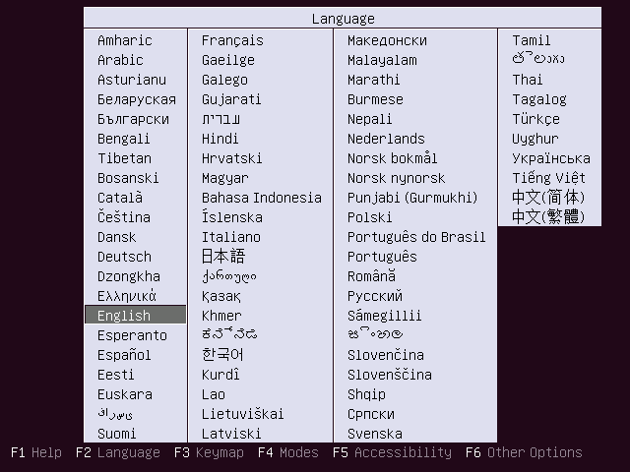Install Ubuntu 17.04 – Installation language

For installing the Ubuntu 17.04, Select Install Ubuntu.

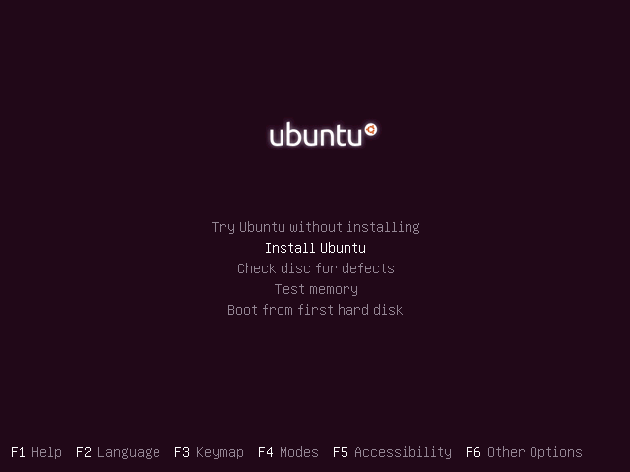Install Ubuntu 17.04 – Menu

This is the starting screen of Ubuntu, and it would disappear in a minute

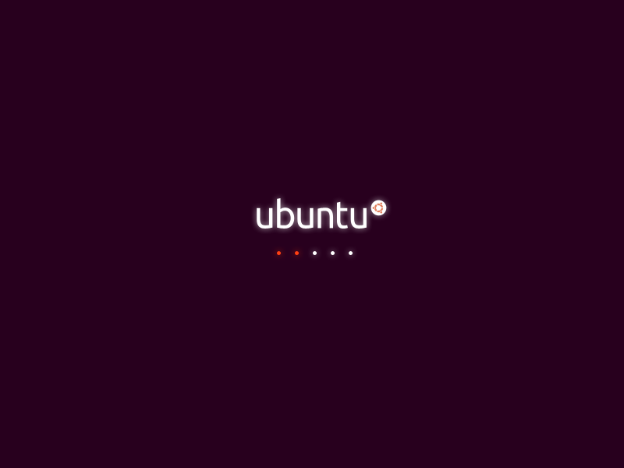Install Ubuntu 17.04 – Starting Screen

Click continue on the welcome screen. You can read the Ubuntu release notes on this screen.

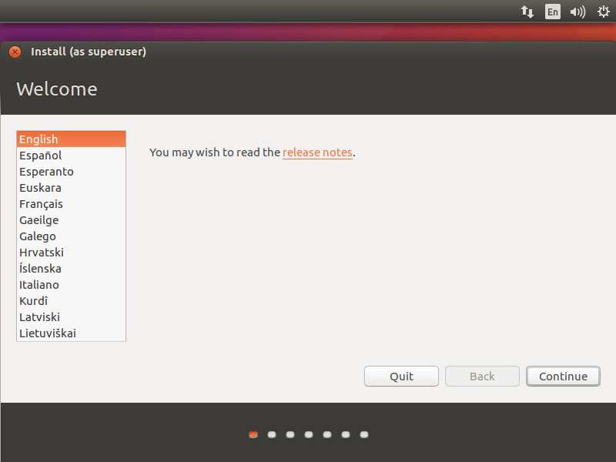Install Ubuntu 17.04 – Welcome Screen

If you wish to install updates and other third-party software while installing Ubuntu 17.04, put a tick mark or leave as it is since it requires internet connectivity. Installation may take an hour-long depends on the downloadable contents.

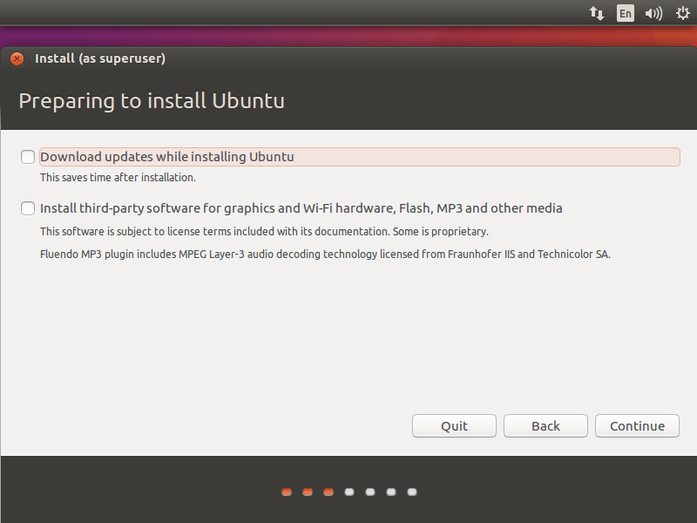Install Ubuntu 17.04 – Preparing Installation

Installation type:

I’m installing the OS on the fresh HDD, so I have only two options in the installation type. Depending on existing OS’s on your HDD, you would get more options.

Please select any one of the methods.

**1. Erase disk and install Ubuntu – It will format the entire hard drive and install the OS.**

If you are unsure what to select, you better to go with this. You just click on Install Now.

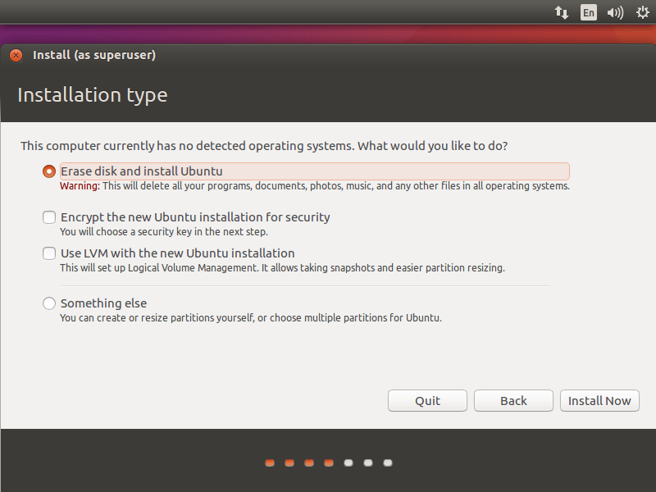Install Ubuntu 17.04 – Installation Type

Now, OS installer will ask you to confirm the auto partitioning. Click on continue.

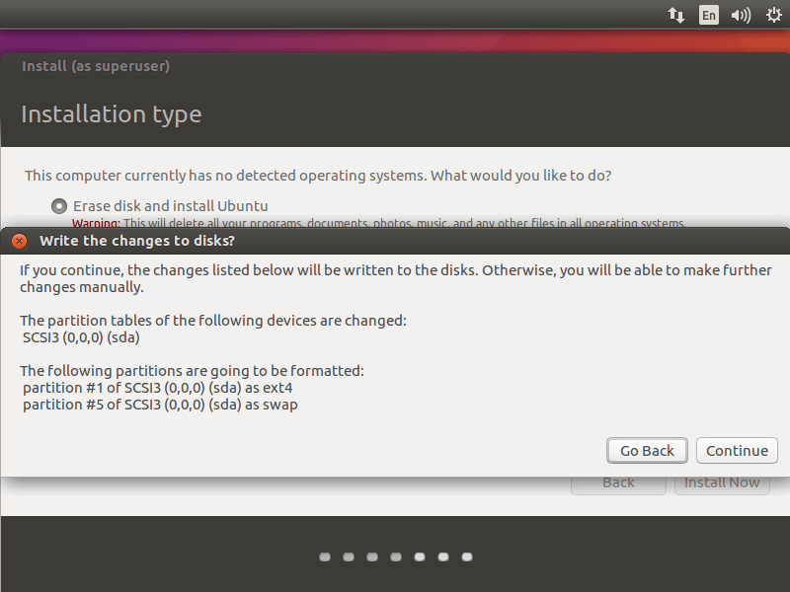Install Ubuntu 17.04 – Erase Full Disk

**2. Something else – You can manually create the partition and install Ubuntu on selected partition.**

Use this advanced mode only if you are comfortable in partitioning your drives manually. Click on continue.

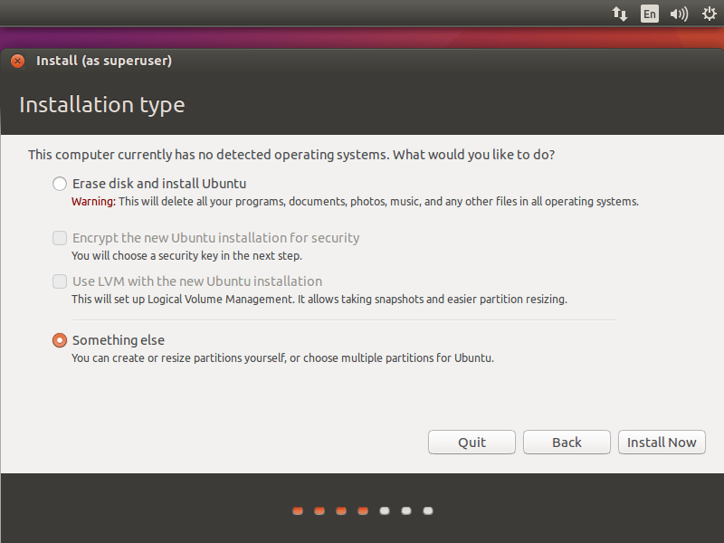Install Ubuntu 17.04 – Installation Type

Once you clicked, installer lists all of your hard disk available on your system. In my case, I have one hard disk with the size of 100GB.

Create an empty partition by clicking on New Partition Table.

As I said earlier, this is a new hard disk. So pop up window will ask you to confirm the creation, click on continue.

My system partition scheme will look like below:

**/boot – 500MB**

**swap – 2 GB**

**/ – 99GB (Remaining space)**

Select “**free space**” and hit “**+ sign**” at the bottom left to create partitions.

Following shows for /boot partition.

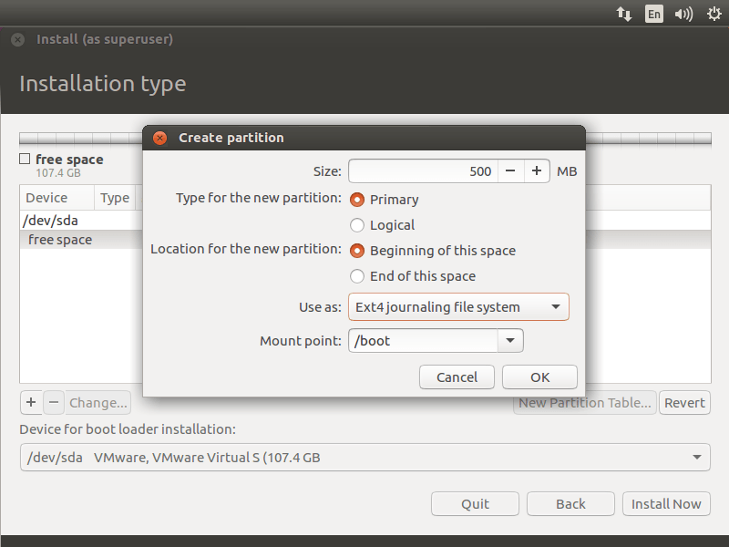Install Ubuntu 17.04 – boot partition

Following screen shot shows for the swap partition, make sure you select**“use as swap area”**

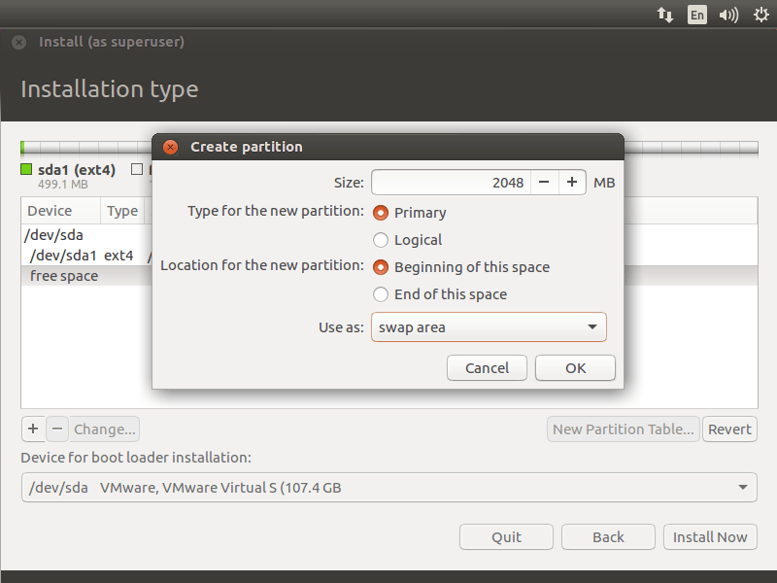Install Ubuntu 17.04 – Swap

Following is for / (root) partition.

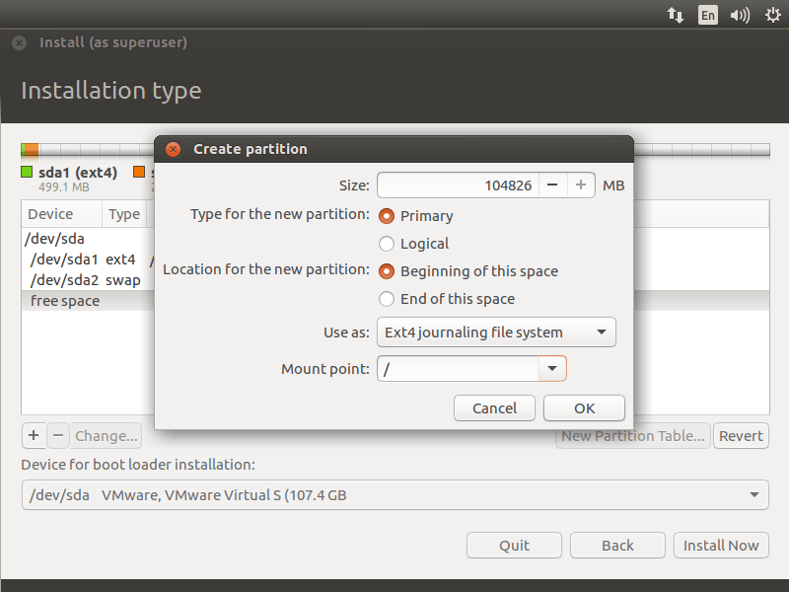Install Ubuntu 17.04 – root partition

Review your partitions and then click on install now.

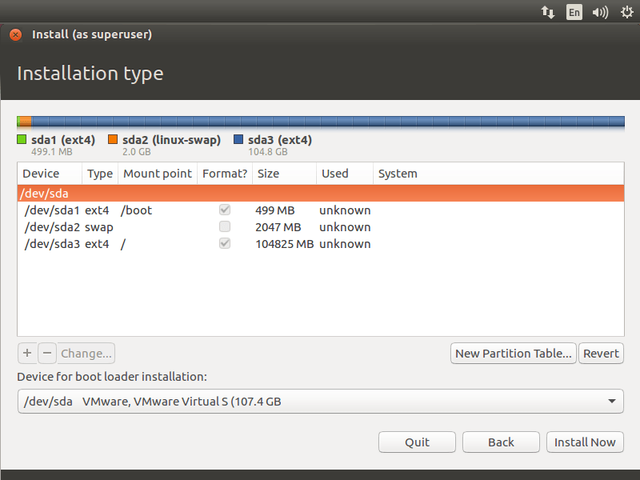Install Ubuntu 17.04 – Partition List

Click on continue to write the changes (partition table information) to disk.

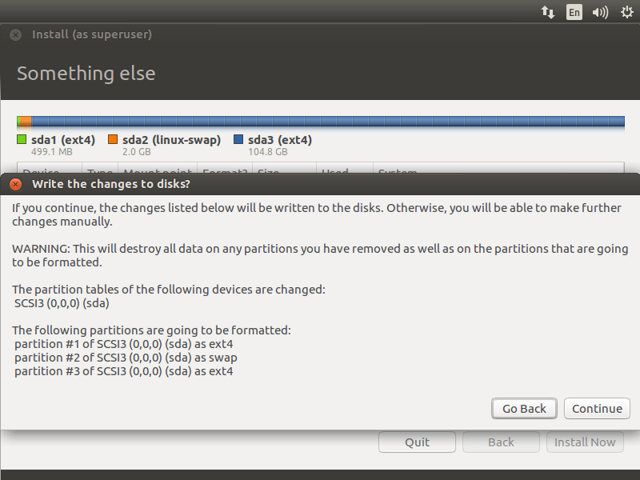Install Ubuntu 17.04 – Formatting Partitions

Select your geographical location next screen.

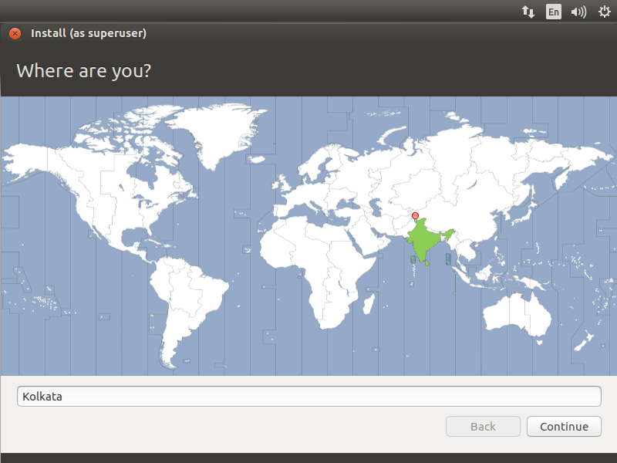Install Ubuntu 17.04 – Select Location

Choose your keyboard layout on next screen. If you are not sure, hit the ‘**Detect Keyboard Layout**‘ to find it out. You have an option test the selected keyboard by typing in the test text box.

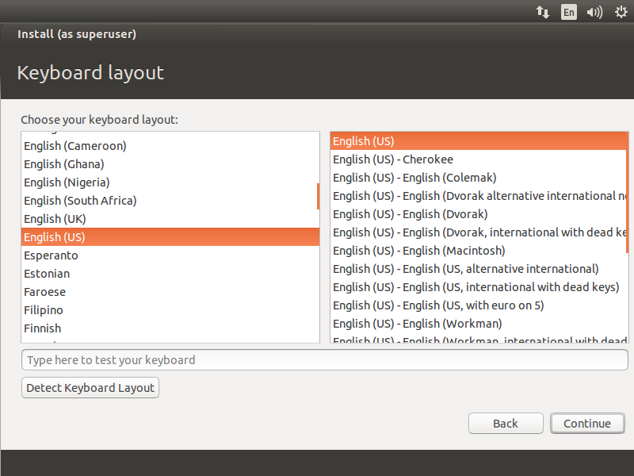Ubuntu 17.04 – Keyboard Layout

On the final stage, the installer will prompt you to enter information of about the user you wanted to create on the system.

Things you should remember – if you choose ‘**Login automatically**‘, System will directly take you to the desktop without asking your credentials.

It’s recommended to enter the complex password for your user. Ubuntu will tell you whether your password is secure or not.

Using ‘**Encrypt my home folder**‘, you can make all the files and folders in your home folder more secure from unauthorized accessing / viewing if you have multiple users using your computer. When you log into your computer, your files will be decrypted for just your session. If you are unsure, better to leave this box unchecked.

Once it’s done, click on continue.

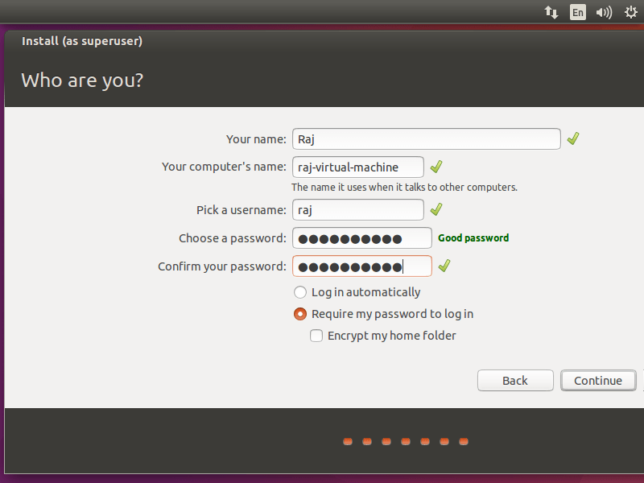Install Ubuntu 17.04 – User

Below screenshot shows installing Ubuntu 17.04.

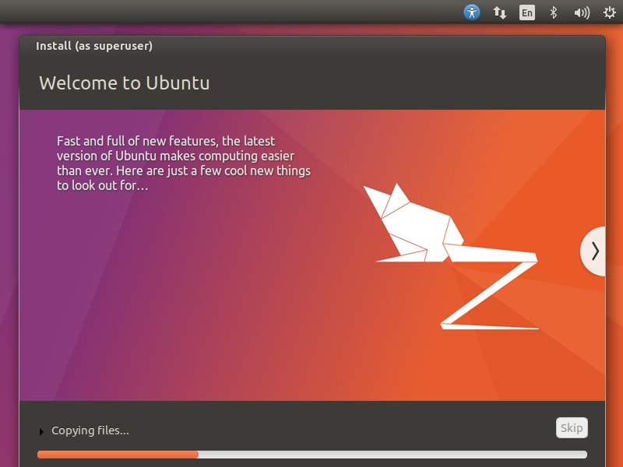Install Ubuntu 17.04 – Installation is in Progress

Once the installation is over, click on restart now.

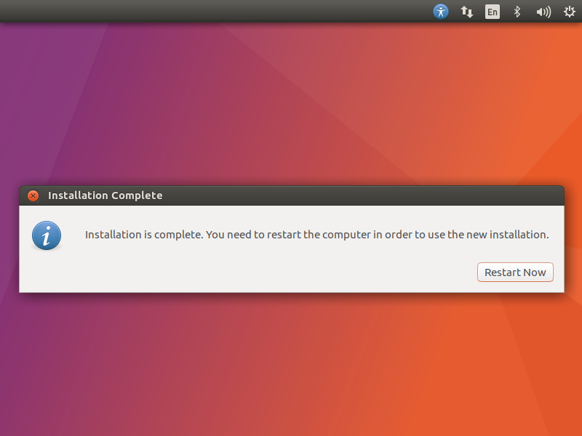Install Ubuntu 17.04 – Installation is complete

**Remove the installation media and press Enter.**

Upon restarted, Enter your username and password you created earlier to login to system.

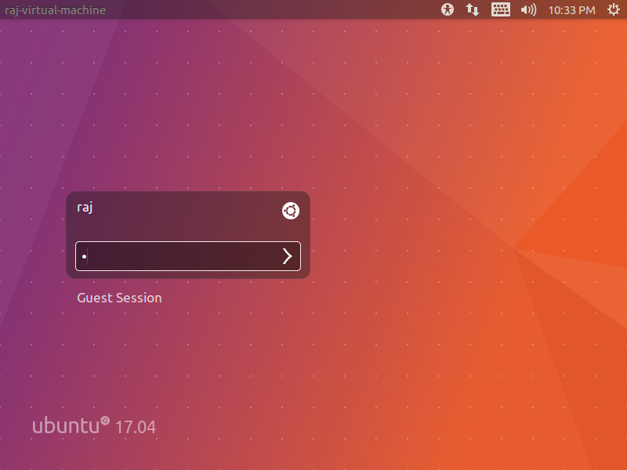Install Ubuntu 17.04 – Login Screen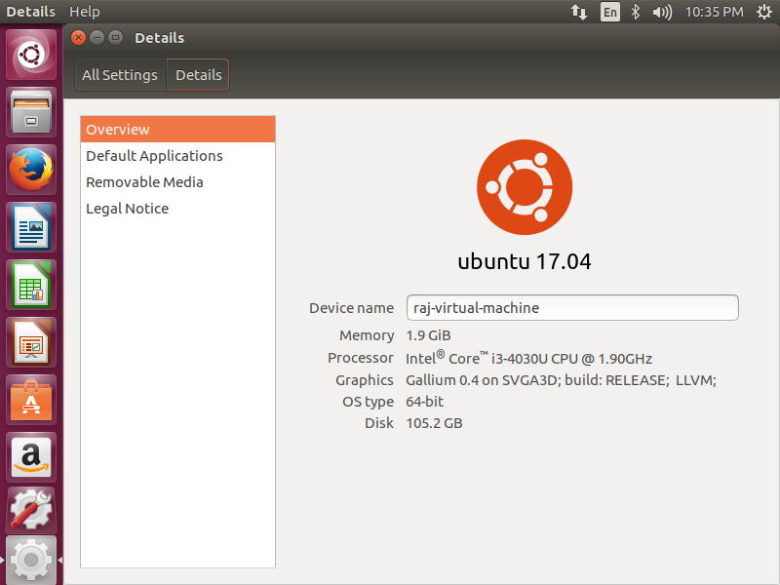Install Ubuntu 17.04 – About This Computer

Ubuntu is now ready for you to try it out!! Use, Share and Enjoy.